COM S/SE 319 : Software Construction and User Interfaces Spring 2019

HW 4

Solution Approach

This program operates by using the JavaFX containers to construct a 3x3 matrix of buttons, all of which are initialized at specific positions and are binded to a cell in the back end which is the one that detects for wins and for turns. Every time a cell is clicked, it runs a method to try and claim it for whoever has the current turn. After being allowed to do so it tries to switch turns. If it has detected that the game was done it will run a series of loops to check for the run of 3 in any direction. If successful it will mark the game as won and finished and increase the score of the player team. If it finds no more empty cells it will trigger it to be finished but not won. When the game’s flag for finished is raised, no more tiles will be able to be claimed.

In the GUI all the buttons are initialized to trigger this method, refresh the counter that tallies the scores of the teams and refresh the text that advertises if the game is over and if there is a winner.

1. Use the provided images (included in the zip file) for marking X and O.


2. Show which player’s turn while playing the game.


3. Click on the blank cell to mark X or O (unmarked cell should be checked and marked cell cannot be marked again).
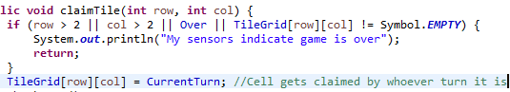

4. When one player wins, stop the game and show “Congratulations, X win the game”
or “Congratulations, O win the game” in your designed GUI.


5. When all cells are filled in and no one wins, stop the game and show “Draw”.
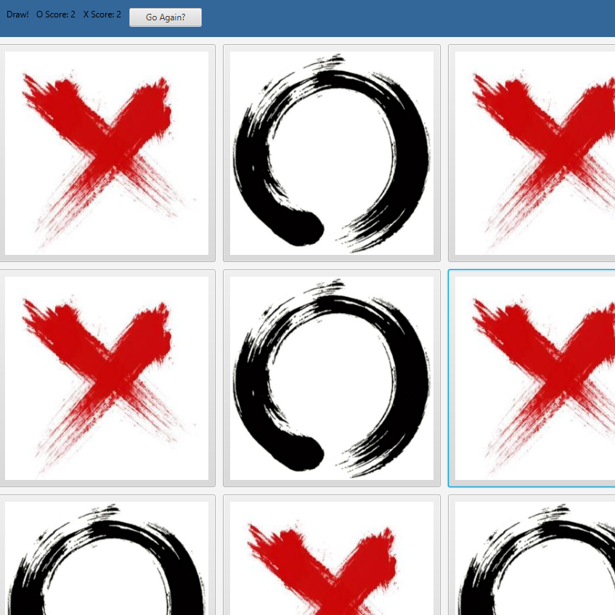
6. When the game is over, show the option to restart a new game.


